Peter Pans Newsletter
We would like to welcome everybody back who has already returned to nursery and we look forward to seeing more of you in the next couple of weeks. We are still running on reduced staff and will be calling them back off of furlough in accordance to children returning. As many of you may be aware Lauren has returned from maternity leave, and we would like to take this opportunity to thank both Danielle and Zoe F for doing such a great job fulfilling her role whilst she has been off. There has been a lot of changes around nursery and the children that have already returned have amazed us and fitted back in like they have never been away. They have adapted really well to our new routines and are happy to follow our new rules. All the children and staff who have already returned to nursery have remained safe and well.
Over the next few weeks, we will be reintroducing a number of activities that we temporarily suspended including water play, messy activities etc. We will continue to put measures in place to ensure these activities remain safe for the children.
A Few Reminders:
- Nursery Opening hours W/C 20th July
Babies and Toddlers (Children under 3) can be dropped off from 8am and collected before 5:30pm
Pre-school children can be dropped off from 8:15am and collected before 5:45pm
(If you have 2 children in different age groups you should drop off at the later time and collect at the earlier time)
- Nursery Opening hours W/C 10th August will return to normal hours 8am – 6pm.
Dropping and collecting will remain from the rear entrance and may be remind you to remain 2 metres from both staff and other parents. Please allow our staff time to collect your child both morning and evening as children will be collected in their room bubbles only. E.g Two parents drop off/collect at the same time, but their children are in different age groups the member of staff will not collect them together they will be collected individually.
- On returning to nursery please ensure your child has a pencil case, clearly labelled with their name with age appropriate mark making materials i.e. crayons, pencils etc. This will help us manage the risk of infection.
- Children should be kept away from nursery at the first sight of being unwell. If your child becomes ill at nursery showing any of the symptoms listed in our sickness policy, we will call you and you will be asked to collect your child immediately. Those children sent home will be required to self-isolate for 7 days and can only return to nursery after this period or if they have received a negative test result for Covid-19.
- If someone a child is living with someone who shows symptoms of or they have had tested positive for Covid-19 the child can only return to nursery after 14 days of isolation or the person showing the symptoms has a negative test. (Please see our sickness policy for more details)
- Communication diaries have been replaced with mini reports. A report will be sent home with your child each day they are in nursery to try and limit face to face communication. If you are happy not to receive a report, please let a member of staff know.
- Should you wish to discuss anything in length please call or email the office.
- Meals will not be written on reports, just how well your child has eaten. It is very time consuming for the staff to write down the meals on each child’s book/report. Menus are displayed on our website.
- Please dress your child appropriately weather providing a warm coat, hat, scarf and gloves for winter and sunhats and sun cream (Factor 30 or above) for the summer.
- Breakfast is served between 8.30-9am, if you wish for your child to have breakfast they need to be at nursery before 9.00am.
- As from 10th August, Nursery closes at 6.00pm, any children left after 6.00pm will be charged the late collection fee, of £25.00 as detailed in our Terms and Conditions.
- Please telephone and let us know if your child is going to be absent for the day, or if you will be going on holiday. This can become a safeguarding issue.
- Nursery Fees are due on the 1st of each month, this includes those paying by childcare vouchers.
- Please remember to update your records with us if you have new contact details, e.g telephone numbers, change of work, address etc.
- Buggy sheds will be re-opened as from W/C 3rd August, please use the hand sanitizer provided before using them. May we also remind you that contents are left here entirely at the owner’s risk.

Dates for your Diary
17th to 21st August – Sport’s Challenge Week
31st August (Summer bank holiday) – Nursery closed
14th September to 18th September – Jeans for Genes Week
31st October – Halloween
9th November to 13th November – Children in Need Week
Please let us know if your child attends another setting. We will write to the other setting asking to share information regarding your child’s progress. We also ask them to complete a settling link sheet, which we will be put into their learning journal.
OUR NEW WEBSITE IS COMING SOON!
(We will let you know once it goes live.)
Like us on our Facebook page to get reminders of diary dates – Type in Peter Pans Day Nursery into the search box.
***We have availability for extra days from October to December for the Pre-school and Toddler rooms. Please contact a member of the office team should you wish to book any***
Preparing your child for school!
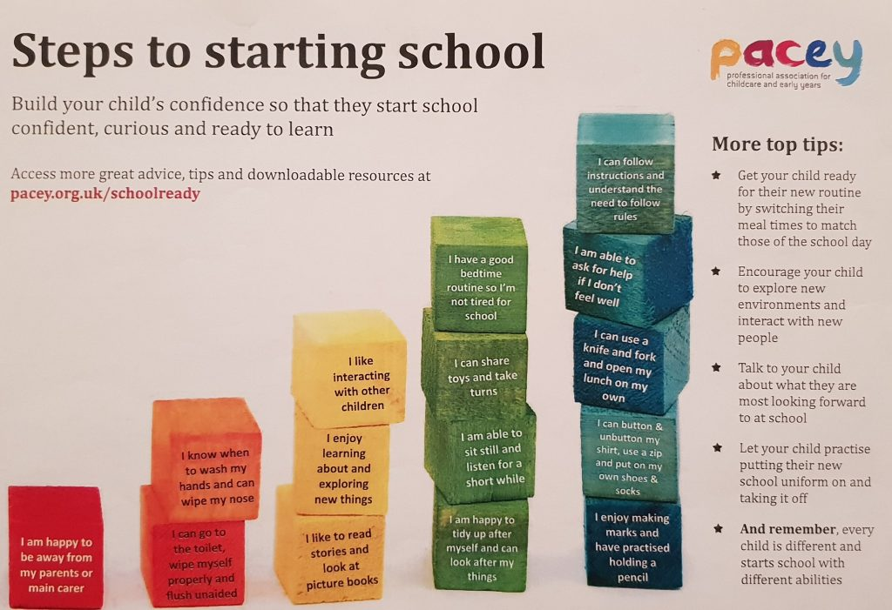

Visit our website for more information or to read our policies www.peterpansdaynursery.co.uk

